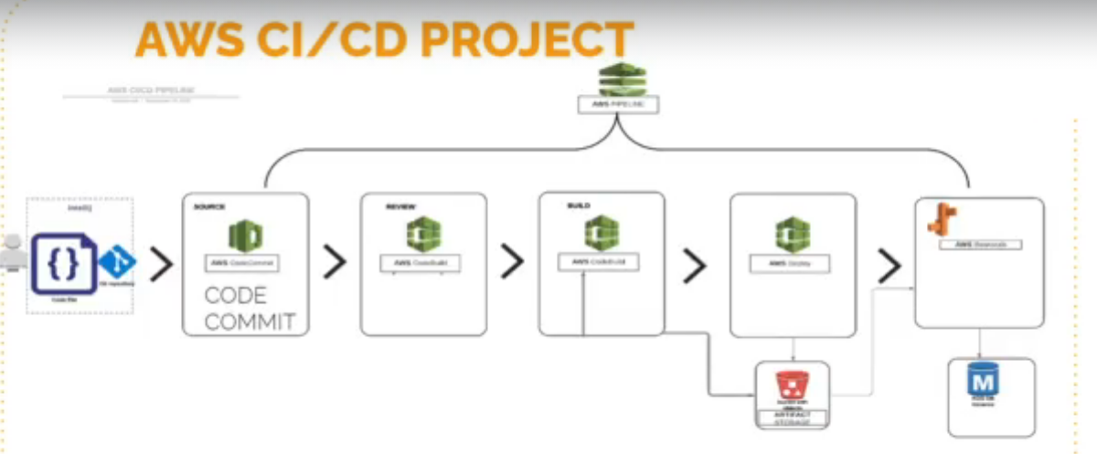

STEPS:

* Go to Elastic BeanStalk and click on create Application (Application name=vprofile-app, ….. platform=Tomcat, …….. click on configure more option …….. click on Software(proxy server=Nginx, scroll down to log streaming=check it, …. then click save) ……. click on edit for instances(root volume type=General purpose SSD, size=8GB, security group=leave it that way and create later, …. then click save), ……click on modify capacity(environment type=Load Balanced, scroll down to availability sones=Any, placement=select all availability zones, scroll down to metric=Networkout, scroll down and click save) …….. Click on Load Balancer(Load balancer type=Application load balancer, scroll down to processes=) scroll down and click on create application)